Smart Wireless Ag Sensors for Measurement of Soil Water Contents
  - Project plan
Team Number: 38
Client: Iowa State University – Research Department
Adviser: Dr. Liang Dong
Team Members/Roles:
Colin Cox – Project Manager – Software Team
Jarrod Droll – Lead Software Testing – Sensor Team
Rachel Hoke – Meeting Organizer – Sensor Team
Wage Miller – Chief Hardware Engineer – Control Box Team
Scott Rowekamp – Chief Software Engineer – Software Team
Tyler Thumma – Lead Hardware Testing – Control Box Team
Team Email: sdmay18-38@iastate.edu
Team Website: http://sdmay18-38.sd.ece.iastate.edu/
Revised: 12-5-17 / v3
Table of Contents
List of Figures iii
List of Tables iii
List of Definitions iii
• Printed Circuit Board PCB - iii
• Ion Selective Membrane - iii
1 Introductory Material 1
1.1 Acknowledgement 1
1.2 problem Statement 1
1.3 Operating Environment 2
1.4 Intended Users and Intended uses 2
1.5 Assumptions and Limitations 2
1.6 Expected End Product and other Deliverables 2
2 Proposed Approach and Statement of Work 3
2.1 Functional/nonfunctional requirements 3
2.2 Constraints considerations 3
2.3 Technology considerations 3
2.4 Safety considerations 4
2.5 Previous Work and Literature 4
2.6 Possible Risks and risk management 4
2.7 Project Proposed Milestones and evaluation criteria 4
2.8 Project tracking procedures 5
2.9 Objective of the task 5
2.10 Task approach 5
2.11 Expected Results and Validation 5
3 Estimated Resources and Project Timeline 6
3.1 Personnel effort requirements 6
3.2 other resource requirements 6
3.2 Financial requirements 6
3.3 Project Timeline 7
4 Closure Materials 7
4.1 conclusion 7
4.2 References 8

List of Figures
- Figure 1. Semester 1 timeline
- Figure 2. Semester 2 timeline
List of Tables
- Table 1. Personal Effort Requirements
List of Definitions
- Printed Circuit Board PCB -
- Ion Selective Membrane -

1 Introductory Material

1.1 Acknowledgement
We would like to thank the following groups/people for their help throughout this project.
- Iowa State University Research Departments
  - Electrical Engineering
  - Agronomy
- ETG - Leland Harker
- Dr. Liang Dong, Dr. Azahar Ali and students (Grad and PhD.)
  - Xinran Wang
  - Yuncong Chen

1.2 problem Statement
As the population of the world increases we need to account for feeding everyone. The problem that the research department is facing is how to improve crop yields within agriculture by looking at the differences between genetics of plants and the chemical levels within plants and soil effected by fertilization. To get this information the electrical and agriculture research departments at Iowa State University, have teamed together and developed plant and soil sensors to collect data for analysis.
Our team is working to improve these sensors, to allow for optimized production, enhanced data collection, and interpretation. We are designing and developing new sensors to be used out in the fields, while creating an updated user interface to access and store data in. There are several changes for improving the current design of the sensors, and they are categorized as follows:
- Improving the control box. Looking at the components and housing.
- Advancing the application used for collecting data. A commercial app is currently being used for data analysis, whose functionality is not user friendly.
- Changing the design of the sensor PCB for an improved fabrication process.
These generalized main changes to our project can be broken into corresponding solutions for each problem.
- For the control box, we would like to decrease the size down to ¼ of what it is currently. This will improve efficiency and reducing power consumption.
- Designing and developing an application that can allow for data extraction and analysis of all the soil and plant sensors simultaneously. Improving the user interface and adding useful functions like a data plot to show trends throughout the season.
- Lastly, we plan on developing and testing new designs for the sensor PCB to improve the chemical application process through use of different tools, covers, and layouts.
In making these improvements the team can help researchers find out what would be the best type of crops to plant in different environments. We can also help farmers determine how much fertilizer will be needed throughout the season. Ultimately this research can be used to help grow better crops increasing their yields allowing for more food and less waste.

1.3 Operating Environment
Our plant and soil sensors will have an operating environment of a corn or soybean field or greenhouse. With that in mind, they need to be waterproof to withstand rain as well as be able to withstand relatively extreme temperature swings depending on a farming location. Additionally, the sensors will be out in the field for anywhere from a few hours to a few days, weeks or months, so sustainability is a key component that we intend to address with a rechargeable battery.

1.4 Intended Users and Intended uses
The intended users for our sensors in the near future are those researching crop yields and corn/soybean farmers. This will begin with researchers in the College of Agriculture at Iowa State University and then be outsourced to other agricultural companies.
The plan is to then have our product used by farmers in order to give them the technology necessary to conduct soil sample testing on their own, rather than having to ship soil out for testing to a third-party company.
We need to make sure that our sensors meet the standards of both intended users, we plan on achieving this by up keeping and improving the accuracy of the sensors and data collection while improving the durability and longevity of the control boxes. Also, we are allowing for easy instillation into the fields.

1.5 Assumptions and Limitations
Assumptions:
- Each control box will have one sensor.
- Sensors will be interchangeable in order to test plants and soil water.
- Plant and soil water sensors can be modified to measure Nitrogen, phosphorous, and potassium.
Limitations:
- The end product needs to be ¼ of original size
- The system must operate under moderate temperature changes (-20 Fahrenheit to 120 Fahrenheit)
- Project budget cannot exceed $2,000.00

1.6 Expected End Product and other Deliverables
Soil and Plant Sensor PCB
A new sensor PCB design/product that improves the fabrication process and accuracy of the sensor.

Software
A simple to use mobile app that will collect the data, display it, and upload it to a remote server for storage. Server sided software to accommodate uploading and viewing of sensor data and other information.
Control Box
An optimized sized data acquisition device that accurately collects and analyses the data received from the sensors.

2 Proposed Approach and Statement of Work

2.1 Functional/nonfunctional requirements
Functional requirements:
- Sensor box ¼ of original size
- The control box will need to run off a coin cell battery for 15-20 mins.
- Can withstand temperatures ranging from –20 Fahrenheit to 120 Fahrenheit
- Portable
- Takes accurate measurements of phosphate/nitrogen/potassium concentration
- Waterproof
Nonfunctional requirements:
- Easy to navigate software interface
- Efficient networking
- Cheap for consumers

2.2 Constraints considerations
Our project will follow standard protocols developed by IEEE, the Code of Ethics. These protocols are applicable to our project as we are working in a team as well as with a client and potentially the public. All decisions will be made ethically and morally in order to ensure proper conduct.

2.3 Technology considerations
On the sensor side of things, we plan to design the PCB for the sensors to be more circular in shape. This can be done on technology such as AutoCAD or Ultiboard. Our intuition tells us that this should be a suitable solution to our current sensors problems. The strengths to our proposed solution are the removal of the conductivity problem and the easier deposition of silver on our PCB. On the control box side of things, the PCB will be redesigned so that is smaller while operating at the same level of efficiency. Software such as Multisim and Ultiboard will be used to do this, as well as a 3D printer in order to create a smaller box to hold the new components.

2.4 Safety considerations
Our group has received training on using the PCB mill and soldering as to avoid any injuries that could occur. We will also have the safety of the public in mind when it comes to our end product as farmers and researchers will be using the devices regularly.

2.5 Previous Work and Literature
Currently these sensors are the first of their kind so all previous work is transferred to us through conversations with Dr. Liang Dong and his graduate students. The circuit and sensor designs were created by them, and some of the other components that are used in the control box are made by Adafruit Industries.

2.6 Possible Risks and risk management
Some possible setbacks currently would be: lack of resources for previously designed circuit, and the sensor re-design process.

2.7 Project Proposed Milestones and evaluation criteria
Our group is split into three groups: sensors, control box, and application. The proposed milestones are listed below:
Sensors:
- Fabricate a working soil sensor. - To test this, we will continually check the conductivity of the sensor throughout the fabrication process.
- Test sensor in soil water with old control box. - To test this, we will use an old sensor and control box on the same soil water as the new sensor and control box and compare the results.
Control Box:
- Reduce the size of the control box PCB. - Test the new PCB design against the old design and compare the results.
- Reduce the size of other components in control box. - Assemble the components of the new control box and test it alongside the old control box and compare the results.
- 3D print a new box for the new control box components.
Application:
- The mobile application shall be able to collect data from the sensors.
- The mobile application shall be able to display the data.
- The mobile application shall be able to upload the data and other information to a remote server.
- The server shall be able to store data and perform basic analytics.
- The server shall have secure authentication.
- The server software shall follow the C.I.A. model.

2.8 Project tracking procedures
Our group will be tracking progress via our timeline as well as using websites such as GitLab and CyBox. We will also be meeting with our client biweekly and corresponding graduate students on a need-to-meet basis.

2.9 Objective of the task
Our teams task is to improve the sensors within the following aspects:
- Fabrication of the sensors
- Efficiency and size of the control box
- Updated application with data collection
- Communication between sensors and app (advance software)

2.10 Task approach
We split our team into three groups: sensors, control box and application development.
Sensors:
We will start by working through the current sensor fabrication process and will document anything in the process that needs improved or re-designs. Next, we will begin developing new designs for the sensor PCB that will serve as a solution to the problems we find during the fabrication process.
Control Box:
We will begin with creating the current PCB design in Multisim and Ultiboard. In order to design the PCB to be ¼ the size we will use both sides of the PCB. We will also look at incorporating the power booster which increases our voltage from 3.7 volts to 5 volts onto our PCB as well to help decrease the size our control box. Finally, we will look at other batteries to decrease the overall size, as the battery is the largest component in the control box.
Application:
Our application will be split it two groups one for the mobile application and the backend web application to support the collection, analysis and storage of data. The mobile application will connect to the control box and poll data. On the app, the data can be display to the user in an easy to understand format. And example of this would be a graph. The app will then upload the data to the server where it will be stored for later viewing. Users will have an account they log into so that multiple clients can use the server without being able to see other users data. The server may also support more advanced analytics like comparing data between uploads. The last function of the server will be the collection of user statistics. Such statistics may include locations, temperatures, or other debug data. This will be used by us to make improvements on the softare.

2.11 Expected Results and Validation
We expect to have new sensor and control box designs finished by the end of the first semester, as well as a rudimentary design of the software application. The second semester will involve fabricating our new sensors and PCB as well as the software application and server software. The expected finished result will be a smaller control box with updated sensors and an easy to navigate mobile application. Validation for our work will be done and approved by our advisor Dr. Liang Dong.

3 Estimated Resources and Project Timeline

3.1 Personnel effort requirements
Name | Task | Explanation
Colin Cox | Software / Application | Working on mainly app-based software.
Jarrod Droll | Sensors | Worked on designing the new sensor.
Rachel Hoke | Sensors | Worked on designing the new sensor.
Wage Miller | Control Box | Worked on a new control circuit design.
Scott Rowekamp | Software / Application | Working on mainly server-sided software.
Tyler Thumma | Control Box | Worked on a new control circuit design.
Table 1. Personal Effort Requirements

3.2 other resource requirements
The resources required for this project include:
- Circuit design components (Resistors, capacitors, op-amps, etc.).
- Circuit design software (Multisim, Ultiboard).
- Chemical solutions necessary for sensor development.
- A server that we can host our server software on.

3.2 Financial requirements
Our team received an allotted budget for this project with the design, manufacturing, and testing of the control boxes, sensor PCB’s and the software application.

3.3 Project Timeline
Semester 1:
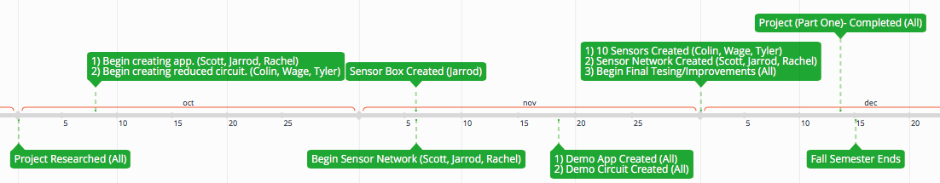
Figure 1. Semester 1 timeline
Semester 2:
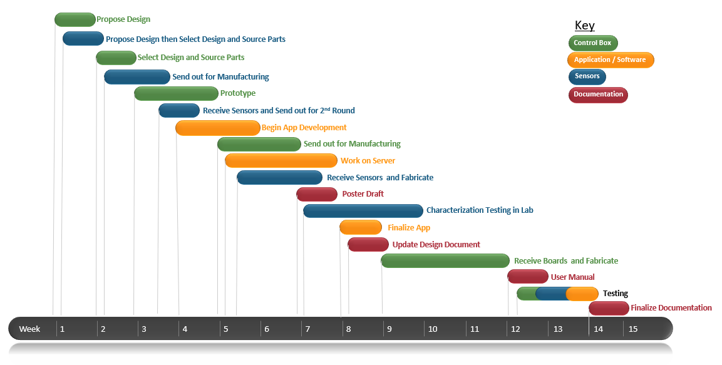
Figure 2. Semester 2 timeline
Throughout the year, we will be focusing on different aspects of the project. We have dedicated our first semester towards learning, designing, and testing the sensors. Once we have completed and finalized our new design plan we will begin work on implementing it within the second semester building multiple sensors and testing them in the field.

4 Closure Materials

4.1 conclusion
Our team is focused on improving the sensors in order to increase their abundance in crop yield research, by doing so researchers will be able to develop higher quality seeds and knowledge on effects of fertilizer. We plan on accomplishing many of our goals for advancing and improving our system, while grow stronger as a team to ensure our clients a successful product. We will accomplish this through research and collaboration with our team and advisors throughout the project timeline.

4.2 References
1.) IEEE Code of Ethics

